**Practicum Report**

Job sheet 3

Assignment 3: Experiment

Variables, Data Types, and Operators



MUHAMMAD BAIHAQI AULIA ASY’ARI

2241720145

CLASS 1I (INTERNATIONAL)

INFORMATICS ENGINEERING­­

INFORMATICS TECHNOLOGY

STATE POLYTECHNIC OF MALANG

Contents

Experiment 1 3

Experiment 2 4

Experiment 3 6

Experiment 4 7

# Experiment 1

1. Change the variable name so that the variable naming model is good and correct!

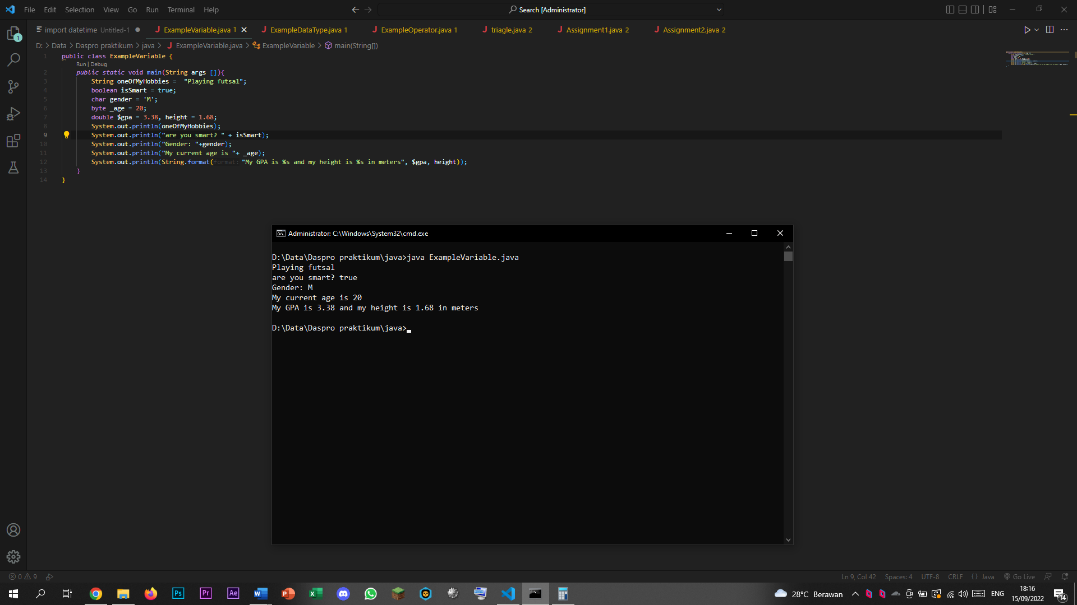

1. Run the code again and then observe the results!

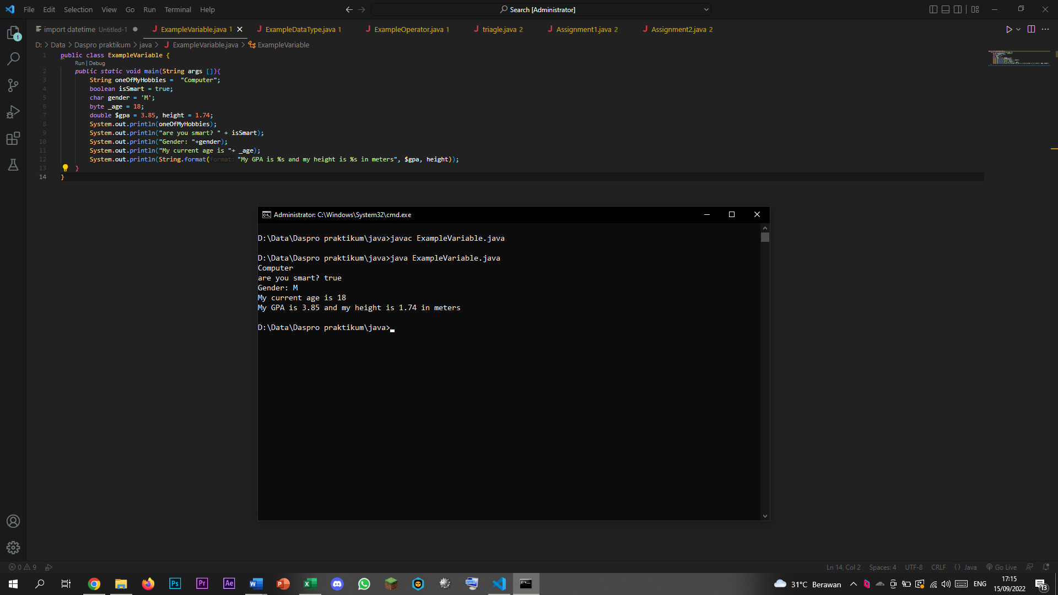

# Experiment 2

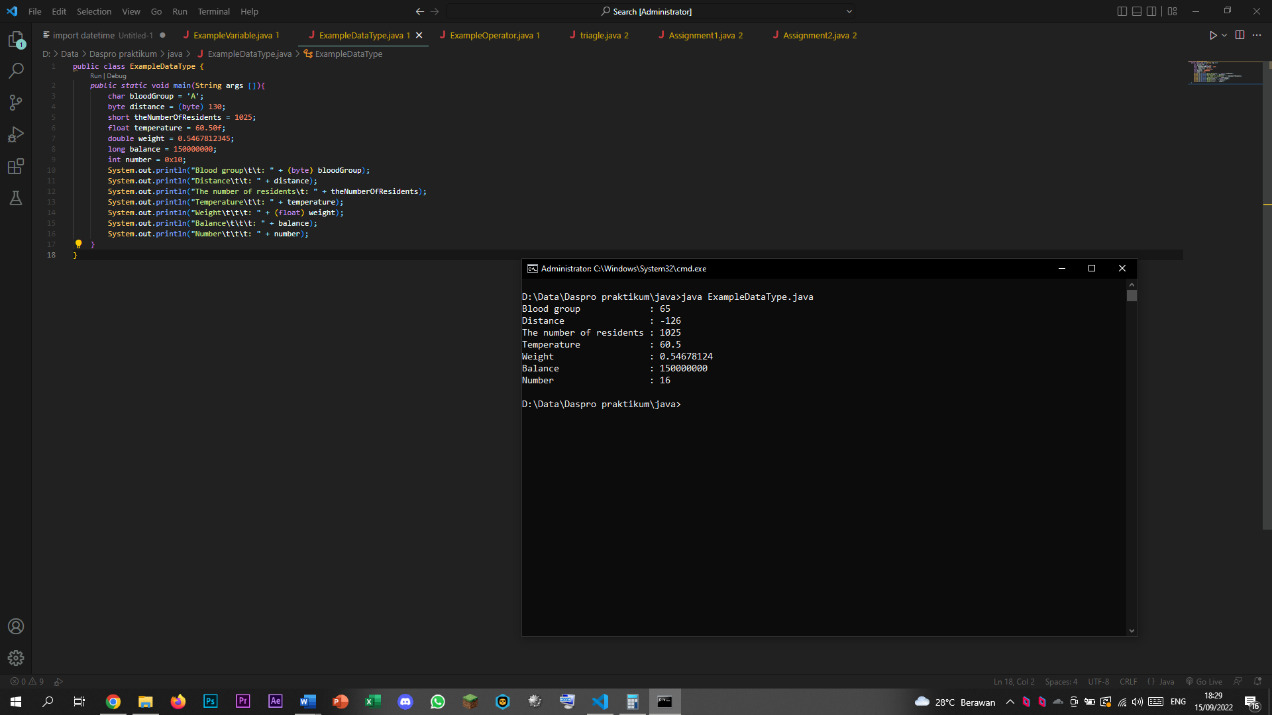

1. Explain why the blood group does not display an "A"!

Answer:

Because the blood group was change in the printing process into byte.

1. Explain the syntax of distance = (byte) 130 bytes! Then, explain why the results change when displayed!

Answer:

Because when an integer was turned into byte and the integer lies out of range of byte range, the byte will cycle back to the start of the byte range.

1. In the syntax float temperature = 60.50F; remove the letter F, then run again. What happened?

Answer:

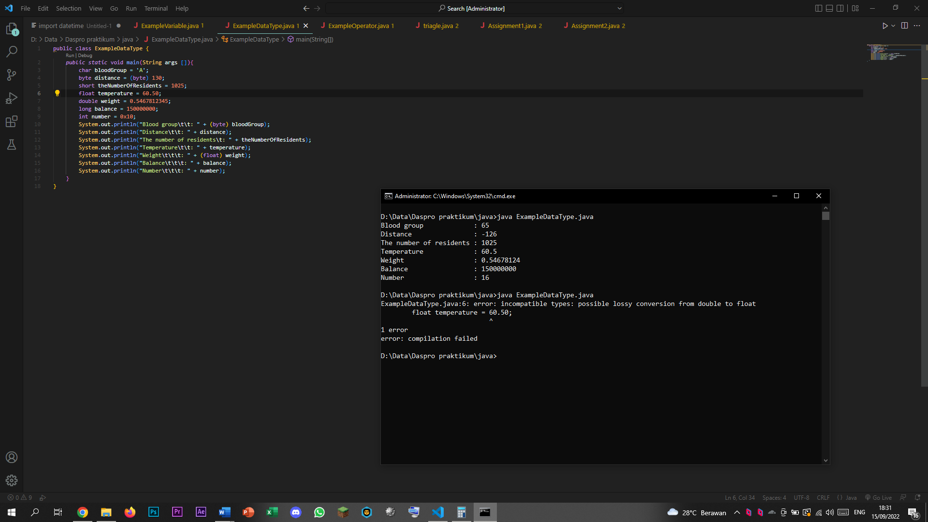

An error occurred, because it can’t tell the difference between double and float. A float number is indicated by number followed by f.

1. Why does the result change when displaying weight values?

Answer:

Because in the process of printing, the weight was converted to float, which has a lower integer limit than double.

1. Explain the meaning of initializing 0x10 on number variables! What does it do?

Answer:

0x10 is a hexadecimal number, when a hexadecimal number (initiated by 0x-) was defined as an integer, it will convert the format from hexadecimal to decimal integer.

# Experiment 3

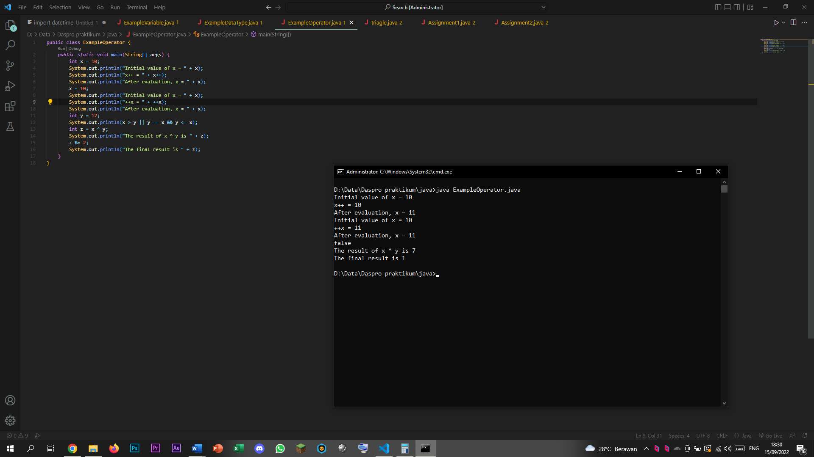

1. Explain in your opinion what is the difference between x++ and ++x!

Answer:

X++ add up the number after declaring it meaning that it actually displays the previous value first and then adding up later, ++X does the opposite, it adds up immediately instead of adding up later, meaning that the value added up first then it displayed the added-up value.

1. What is the result of int z = x ^ y; do the calculations manually (you can use a calculator)!

Answer:

Z = X ^ Y

X = 11 in binary is 1011

Y = 12 in binary is 1100

Passing X and Y trough bitwise XOR operator would result in 0111 which is 7

In which the remainder of 7 divided by 2 is 1

# Experiment 4

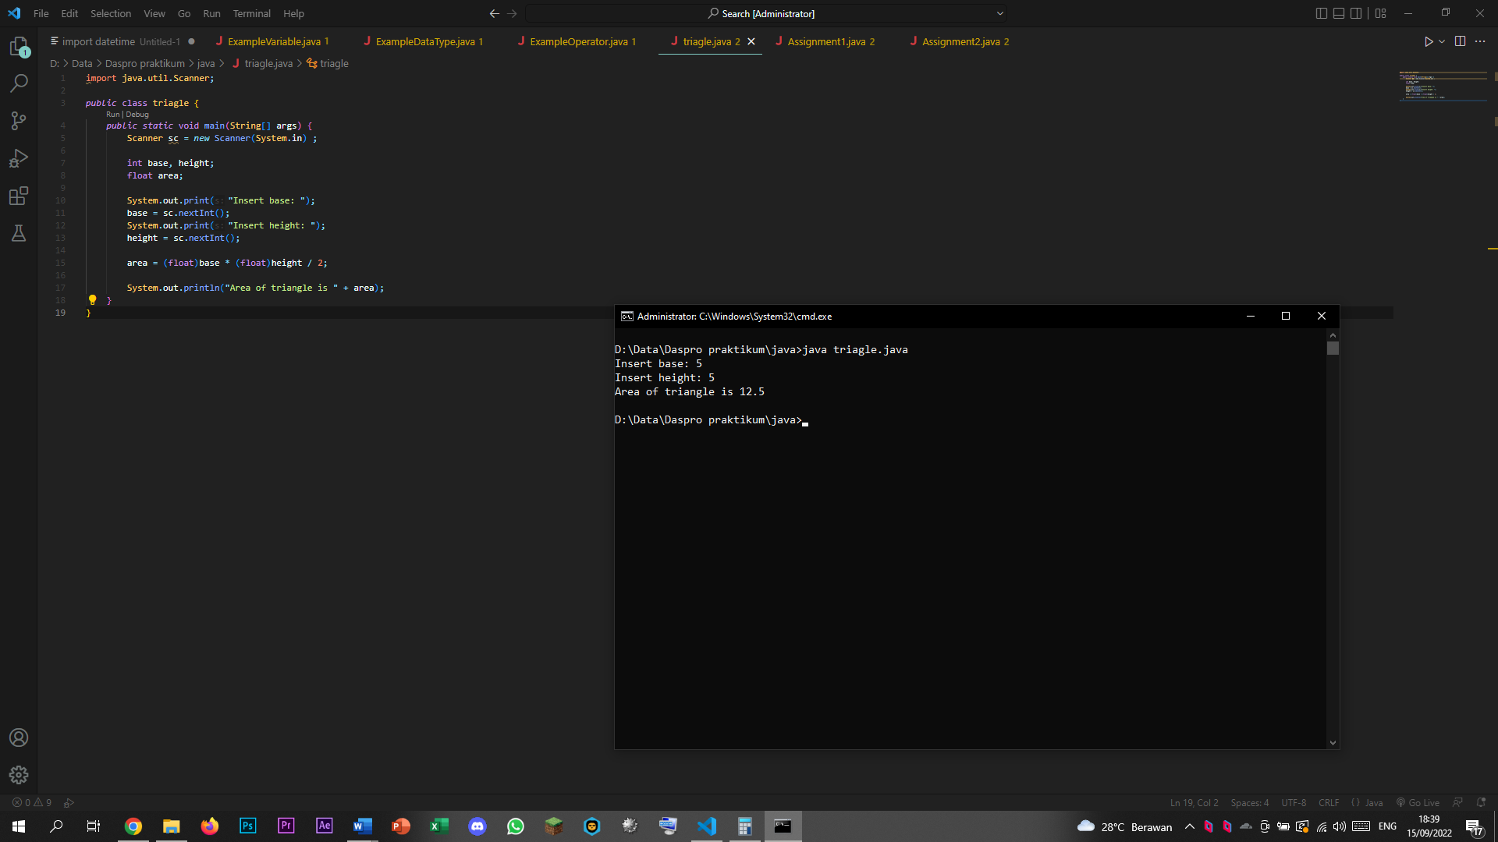

1. Explain why the float data type is used for the variable area!

Answer:

Because the result of the calculation may result in fractional decimal number.